**Coimbatore Institute of Technology**

**Pre-Assessment Test – Curnue**

**Task-01**

**Name : Suruthi R**

**Roll no : 1832054**

**M.Sc Data Science**

**Ques : SD03Q012**

**Task:**

Explore the given brazil house rent data set using EDA techniques visualize the results and build a suitable model to predict the house rent.

**Dataset :**

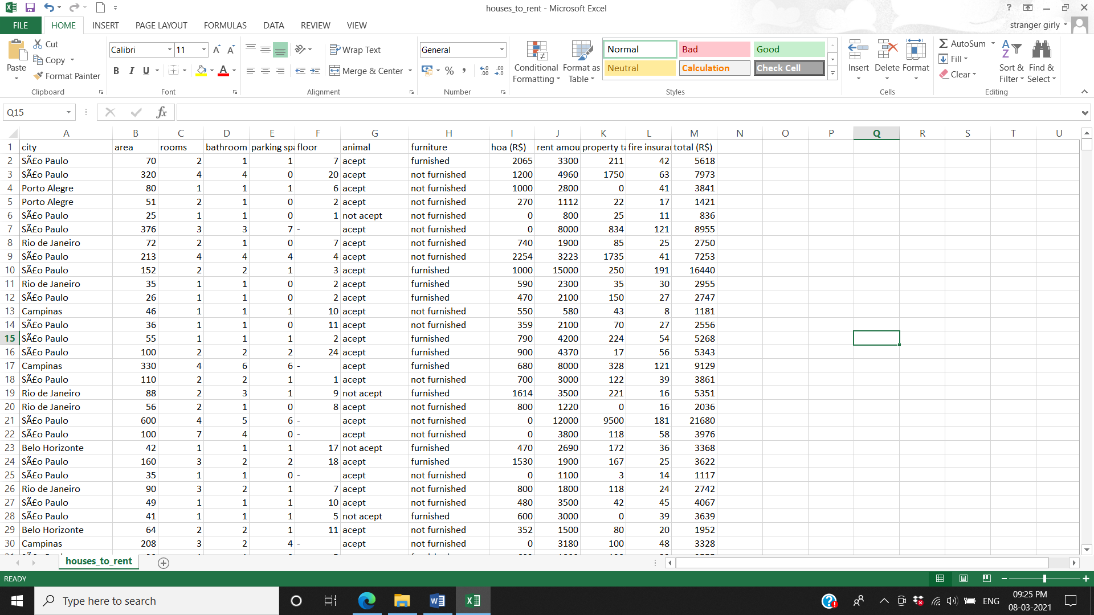

* City :The city in which the reside
* Area : Area for the room
* Rooms : Number of rooms in the house
* Bathroom: Number of bathrooms in the house
* Parking spaces: Total number of parking spaces available in that house.
* Floor: Total number of floor available in that house
* Animal: Is Animals allowed in the house
* Furniture: Is the house furniture or not
* hoa (R$)
* rent amount (R$): The rent amount for that house
* fire insurance (R$): The amount for the fire insurance (R$)
* total (R$): The total rent amount for that house
* **Description:**

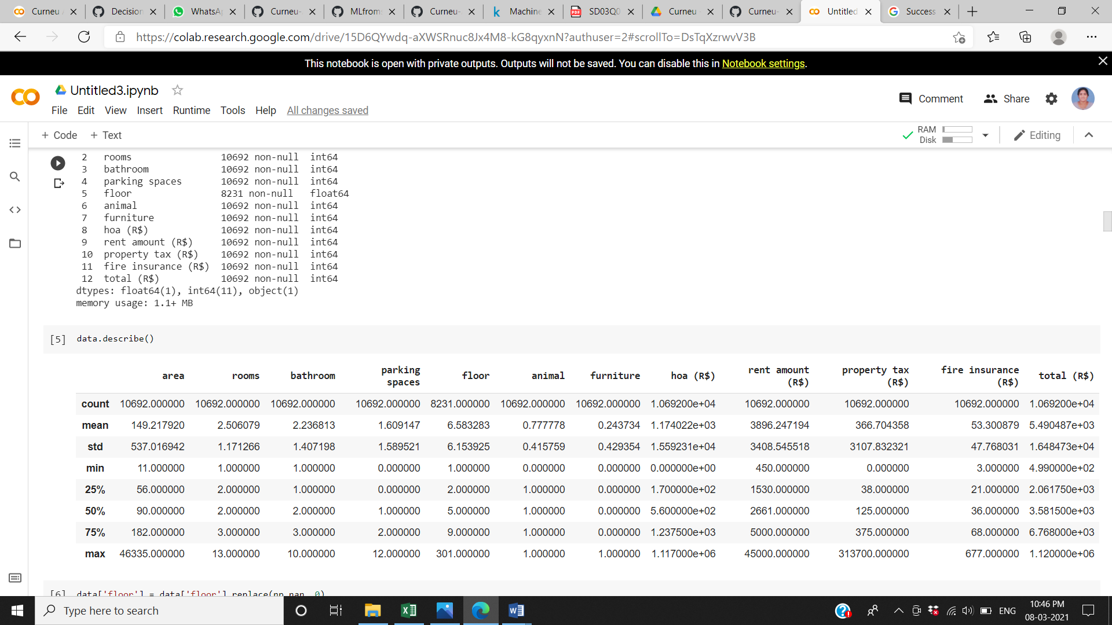

Above table shows that mean, minimum, maximum, quartiles, standard deviation and count of each variable that have numerical values.

**Tools and Technologies used:**

Google Colaboratory (Colab) - Colab allows anybody to write and execute arbitrary python code through the browser, and is especially well suited to machine learning, data analysis and education.

Language Used: Python 3

Tools used:

* NumPy
* matplotlib
* pandas
* sklearn

**Output:**

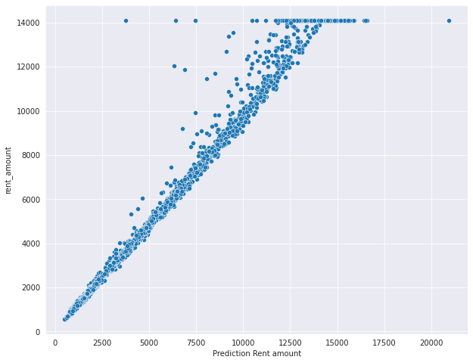

**Conclusion:**

From the graph it is visible that as the rent amount increases the predicted rent amount will also be becoming high.